Safeguarding (Children and Adults) Policy

Author: | Emma Thornber
Approved by: | Sarah Swanson
Last full review date: | February 2022
Updated: | June 2022
Date of next review: | June 2023

This document relates to:

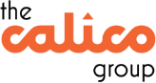 | ✓ | 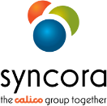 | ✓ |  | ✓
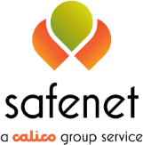 | ✓ |  | ✓ |  | ✓
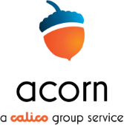 | ✓ | 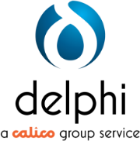 | ✓

CONTENTS

1. | Policy Summary | Page 3
2. | Related Documents | Page 5
3. | Applicable Legislation | Page 5
4. | Safeguarding Systems and Processes | Page 6
5. | Safeguarding Roles and Responsibilities | Page 7
6. | Our People | Page 10
7. | Our Communities | Page 11

Policy Summary
This policy sets out Calico’s group-wide approach to safeguarding. Safeguarding children, young people and adults means protecting a person’s
right to live in safety, free from abuse and neglect.

Within Calico we operate a zero-tolerance approach to neglect, degrading treatment, unnecessary or disproportionate restraint, and/or the deprivation of liberty.

We will:

  - safeguard individuals in a way that supports them in making choices
(“Making Safeguarding Personal - MSP”) (empowerment)
  - prevent harm and reduce the risk of abuse or neglect to adults within our services (prevention)
  - support people in a way that meets their needs and best interests (proportionality)
  - support and represent people when they need protecting (protection)
  - work in collaboration with other professionals and local communities (partnership)
  - always be transparent and share information safely and appropriately (accountability).

We will do this by:

  - ensuring that all our safeguarding systems and processes are person- centered, compliant, and effective (Page 5)
  - ensuring that roles and responsibilities in relation to safeguarding are clearly laid out (Page 6)
  - ensuring that all our people know how to recognise, respond, report, record and refer (Page 9)
  - playing our role in ensuring strong multi-agency safeguarding frameworks within our communities (Page 10).

We will measure compliance against this policy using the following measures:

  - Everyone who works within Calico Group knows what signs and indicators of abuse to look out for and who to contact for advice and support, demonstrated through our Safeguarding audits and regulatory inspections.
  - Calico Group reports and responds in a timely and effective way to concerns about abuse.
  - Individuals have access to the support and services that they need from their Business Units within Calico Group and the Group Designated Safeguarding Lead
  - People have their voices heard within safeguarding procedures and services.

  - We maximise their rights to choice and control, within the confines of their mental capacity and competence.
  - Children and adults are protected when necessary and have improved quality of life as a result.
  - Calico Group recognises that safeguarding children and adults is a shared responsibility and will ensure appropriate arrangements are in place to co-operate with the local authority in the operation of the safeguarding partnerships.

We will achieve best practice by:

  - Ensuring all services take appropriate action, in a timely manner to safeguard and promote the welfare of all customers.
  - Ensuring responsibilities and procedures are fully understood and that everyone can recognise the signs and indicators of abuse or neglect and respond to them appropriately.
  - Ensuring all relevant safeguarding policies and procedures and regularly reviewed and remain fit for purpose, meeting local and national guidance with all statutory requirements in place.
  - Sourcing and providing up to date relevant and specialist training to identified cohorts of staff as identified by the organisations regularly updated training needs analysis.
  - Participating in, and disseminating learning from, serious case reviews and safeguarding adult reviews to all services as appropriate.
  - Hearing the voice of individuals and making safeguarding personal for adults, young people and children through all safeguarding investigations and enquiries.
  - Maintaining current, and forging new, collaborative relationships with relevant partner agencies within the local authority safeguarding partnerships, NHS Trusts or other stakeholders relevant to the service.
  - Actively participating in internal and multi-agency audits to inform best practice
  - Identifying safeguarding themes and trends within services, geographic areas or service user groups to target learning and development within those services identified within the analysis.
  - Maintaining and developing our knowledge and expertise within the safeguarding arena including the authorship, involvement and dissemination of lessons learnt within local safeguarding enquires, serious case reviews and safeguarding adult/children at risk reviews.
  - Disseminating learning and development recommendations from all key enquiries.
  - Undertaking audits relevant to our safeguarding practice
  - Monitoring lessons learnt and service developments to be assured learnings have become embedded in practice.
  - Utilising cross agency systems to ensure a multi-agency/multi- disciplinary approach to safeguarding.

Related Documents

This policy should be read in conjunction with the following documents:

  - Safeguarding Protocols of each Business Unit
  - Internal audit programme
  - Policy review schedule
  - Group HR policies and procedures

Applicable Legislation

This policy outlines how we will meet our legislative requirements in relation to:

  - The Care Act 2014
  - CQC Regulations
  - The Health and Social Care Act 2008 (Regulated Activities) Regulations 2014
  - Data Protection Act 2018
  - The Health and Social Care Act 2008 (Regulated Activities) (Amendment) Regulations 2015
  - Children Act 1989
  - Children Act 2004
  - Children and Young Persons Act 1933
  - Equality Act 2010
  - Equality Act 2010: Chapter 1 (protected characteristics) Chapter 2 (prohibited conduct) and Chapter 3 (services and public functions)
  - Human Rights Act 1998
  - Mental Capacity Act 2005
  - Mental Capacity Act Code of Practice
  - Mental Health Act 1983
  - Mental Health Act 2007 and Code of Practice
  - Protection of Freedoms Act 2012 – links to The Protection of Freedoms Act 2012 (Disclosure and Barring Service Transfer of Functions) Order 2012
  - Safeguarding Vulnerable Groups Act 2006

Systems and Processes

This policy and related documents (see 2 above) outline the safeguarding systems and processes in place across Calico. Collectively, they ensure that all Business Units comply with all applicable legislation, guidance, and best practice in their fields.

The policy shares the key principles behind our approach to safeguarding, and the legislation and guidance that we comply with.

The protocols establish the ‘how’. They outline our person-centred and transparent safeguarding practice in each Business Unit, whilst providing a ‘step-by-step’ guide for staff.

All documents are readily available on the company intranet (QUIP) and are on display in service locations as appropriate. This is to ensure that staff always have immediate access, and that the people who use our services can read about our approach to safeguarding.

The Head of Governance and Assurance - Syncora reviews this policy as part of our monitored policy review process. Reviews will also take place upon the release of new or amended legislation/guidance, or newly identified improvements to practice.

Learning and development recommendations from all key enquiries, and lessons learnt in-house, are disseminated to each Business Unit via the Care Governance Group (CGG) or Regulatory and Compliance Group (RCG) as appropriate (see section 5 below). Cross company learning is a priority for the Group as we know that learning from each other, and growing together, is a unique benefit of being part of a multi-disciplinary Group structure.

Each area will review their company/service protocols in line with the policy review schedule, monitored by the CGG/RCG. They will do this in conjunction with their local partners to ensure a collaborative approach and to influence consistently reviewed and improved practice.

Those staff responsible for reviews ensure they consistently develop their knowledge and expertise within the safeguarding arena.

Safeguarding systems and processes are additionally reviewed as part of the internal audit programme to identify areas of best practice and/or areas for improvement.

Roles and Responsibilities

Safeguarding is everybody’s responsibility.

All Calico staff have a responsibility for the safety and wellbeing of their colleagues, and of the people who use our services. All staff must follow this policy, and the protocol relating to their business area.

All Calico Staff members and Volunteers are required to attend mandatory safeguarding awareness training upon commencing their role and attend regular re-fresher training.

All Staff Members and Volunteers have a role to play in preventing harm or abuse occurring and in taking action where concerns arise.

Safeguards against poor practice, abuse, neglect, and exploitation need to be an integral part in the delivery of care and any child, young person, or adult at risk of abuse, neglect or exploitation should be able to know how to tell us and to know that they will get a consistent response and for appropriate interventions to take place.

Group managers are required to be familiar with the specific Local Authority procedures that pertain to their service location(s).

Group leaders and managers are responsible for ensuring that staff teams and services have access to the relevant Local Authority procedure and are supported to escalate concerns as required.

Group leaders and managers are responsible for ensuring their staff teams are supported to access regular safeguarding training and have opportunities to increase their knowledge and understanding of what role they play within safeguarding.

Each company’s Senior Leadership Team (SLT) and designated Safeguarding Leads ensure that systems and processes operate effectively within their individual companies.

The named safeguarding leads in each Business Unit are the first port of call for safeguarding issues or concerns, they also ensure that the importance of safeguarding is communicated within their areas of responsibility and can advise staff on matters pertaining to safeguarding.

Group Business Service Leads in collaboration with Calico Homes, Ring Stones and Syncora Leads are responsible for ensuring all staff members and volunteers are subject to safer recruitment procedures and such information can be shared with external regulators as required.

For Syncora, the Syncora Care Governance Forum will provide assurance to the CEO, Executive Leadership Team (ELT) and Group DSO that safeguarding policies and procedures are up to date and that safeguarding activity is analysed to identify any trends and to ensure investigations are carried out as required with any learning shared (where appropriate).

For Homes and Ringstones, the Governance and Regulatory Group will provide assurance to the CEO, Executive Leadership Team (ELT) and Group DSO that safeguarding policies and procedures are up to date and that safeguarding activity is analysed to identify any trends and to ensure investigations are carried out as required with any learning shared (where appropriate).

SLTs / Safeguarding Lead

CGG / RCG

Boards

Group safeguarding will be monitored and governed by the Calico Designated Safeguarding Officer (DSO) – the Managing Director of Syncora. The Group DSO has delegated responsibility from the CEO for ensuring there are robust systems, process, procedures, and policy in place that support compliance with national and local standards for safeguarding.

The Group DSO will provide assurance to the Boards, CEO and Executive Team that safeguarding is monitored, through audit and within the Syncora Care Governance Forum and the Governance and Regulatory Meeting.

The Group DSO will provide operational support and guidance to designated safeguarding leads across the Group and support individual staff members and volunteers where appropriate.

The Executive Team monitors safeguarding audits and activity within their areas of responsibility.

The Chief Executive has delegated authority from the Group Board for ensuring compliance with national and local standards that are reflected in the organisations policies.

Calico Group Board and the individual business unit Boards for Calico Homes, Ring Stones and Syncora. The Boards have responsibility for the oversight of safeguarding systems, process, procedures and policy. They do this primarily through the Group Designated Safeguarding Officer, the CEO, Executive Leadership Team and the Managing Directors with supporting information and evidence.

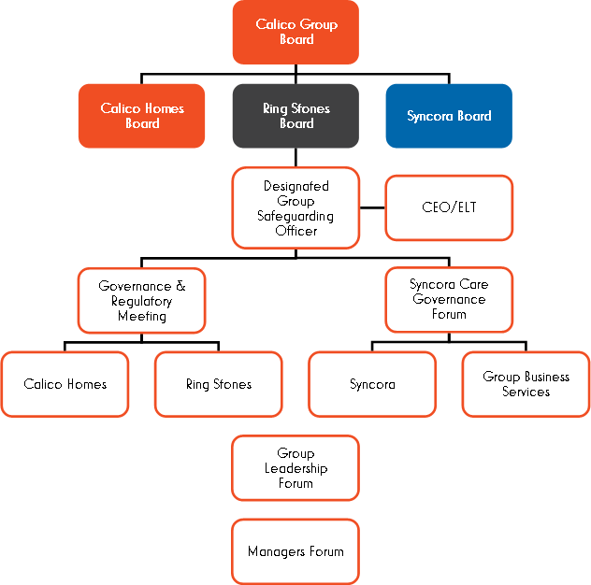

The effectiveness of our safeguarding roles and responsibilities are reviewed as part of the internal audit programme.

Continuous improvement and compliance in quality and safety outcomes will be achieved using data collection for the population of safeguarding information as well as audit and monitoring of compliance with policies and procedures.

Our People

Calico recruit appropriately qualified/experienced employees, via safe recruitment processes overseen by our HR department and implemented collaboratively with hiring managers. This helps to ensure suitability and safety.

Upon joining Calico, all staff undertake a corporate induction, which includes bespoke safeguarding training and area specific process information.

Our people are made aware of their individual responsibilities to recognise, respond, report, record and refer via the above induction process and as part of annual refresher training.

All staff read this policy (and their individual company/service protocol) and understand their role and associated responsibilities. Management support is provided where required.

Annual safeguarding training is mandatory for all Calico staff members, irrespective of role held. This is monitored by the Learning & Development Department, in conjunction with the Head of Governance and Assurance – Syncora. Additional training is also provided and encouraged.

All staff undertake mandatory Mental Capacity Act training and work within the requirements of this Act. We ensure that all adults are included in decision making where able to do so.

All staff understand their individual responsibilities in preventing discrimination in relation to the protected characteristics set out in S4 of the Equality Act 2010. All staff undertake mandatory annual training on equality, and work within the parameters of the company’s Equality policy. This is to ensure that everybody coming into contact with our services will be treated with respect, in a manner that is not degrading, and not be deprived of their liberty for the purpose of receiving care or treatment without lawful authority.

All managers across the company are provided with Leadership Training and understand how to support their staff in dealing with issues, including domestic abuse.

Extended support is available and provided to both staff and management via the supervision and ‘My Time’ process. There are further additional support mechanisms in place including telephone or face to face counselling. This support is available to our people 24 hours a day, 365 days a week.

Staff understanding of systems and processes is managed within each service. Instances of non-compliance with this policy or related protocol is dealt with via our company HR policies and procedures. Assessment of compliance against policy is overseen by the Head of Governance and Assurance, and conducted via our audit process.

Our Communities

We will actively take notice to all information received by the company, including complaints and incidents. Where potential abuse is identified preventative actions will be taken, including escalation where appropriate, in line with individual service protocols. We do not rely solely on reported concerns to tackle safeguarding issues. We actively listen.

We recognise the importance of working in partnership with a wide range of statutory and non-statutory services, and the importance of sharing information appropriately.

We work in partnership with other relevant bodies, sharing information in line with this policy and associated protocols, contributing to individual risk assessments, MARAC, serious case reviews, and regularly review outcomes for people using our services to prevent repeated abuse.

Our policies and processes are discussed with relevant Local Adult Safeguarding Boards to ensure suitable alignment and to ensure we play a collaborative and effective safeguarding role in the communities we work in. A key guiding principle here is not working in silo, and ensuring we are sharing information appropriately and safely to prevent harm.

