Title: Group Complaints Policy

Author: | Sharon Graham
Approved by: | Mark Beach
Date of First Issue: | September 2016
Last full review date: | March 2020
Updated: | May 2021
Date of next review: | May 2024

This document relates to:
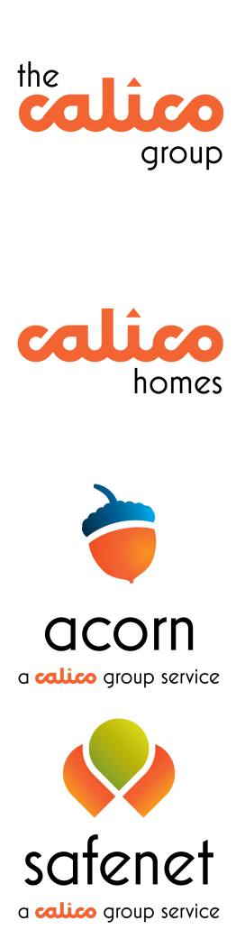

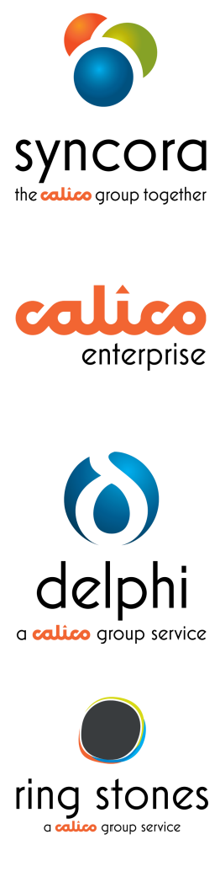

 | ✓ |  | ✓
 | ✓ |  | ✓
 | ✓ |  | ✓
 | ✓ |  | ✓

POLICY AMENDMENTS

Review Date | Revision Description | Reviewed By | Date
May 2021 | The Group Complaints Policy has been updated as part of the scheduled annual review.  The main changes are:  - Complaints now follow a two-stage process, which is a requirement of the Housing Ombudsman’s Complaint Handling Code  - Updated response timeframes for Delphi complaints | Sharon Graham | 25/05/21

CONTENTS PAGE

.................................................................... 1

- EXECUTIVE SUMMARY 4
- AIMS AND OBJECTIVES 4
- CUSTOMER SERVICE STANDARDS 4
- POLICY SCOPE 4
- DISSATISFACTION (informal complaints) 4
- COMPLAINTS OVERVIEW 5
- COMPLAINT STAGES 7
- LEARNING ACTIONS 8
- PERFORMANCE MEASURES 9
- RESPONSIBILITY 9
- REGULATORY AND LEGAL COMPLIANCE 9
- CONSULTATION 9
- BENCHMARKING 9
- GROUP RELATED STRATEGIES, POLICIES AND PROCEDURES 9

EXECUTIVE SUMMARY

This policy sets out our approach towards customer complaints, to ensure a consistent, high-quality, and person-centred complaint handling service across the Calico Group.

We actively encourage all customer feedback, positive or negative and we use this to help us drive improvements to our services. We encourage staff to have a positive approach, take responsibility, show empathy, use common sense, and make good decisions when providing solutions to customers concerns.

Customers can tell us about their concerns in the way that suits them, by telephone, in person, email, letter, via social media, websites, leaflets and customer satisfaction surveys.

AIMS AND OBJECTIVES

Policy objectives
  - To have a clear approach on the handling and resolution of complaints that require an investigation.
  - To make it easy for customers to report and for staff to resolve customer dissatisfaction and complaints.
  - To learn from problems and take action to reduce the chance of recurrence.
  - To achieve the regulatory and legislative requirements on complaint handling that apply to each business within the Group.

CUSTOMER SERVICE STANDARDS

Each company within Calico Group has service standards which outline what customers can expect from the services we provide. We aim to deliver high levels of customer service, care, and support and recognise that any shortfalls against those standards may result in customer dissatisfaction or a complaint that requires an investigation.

POLICY SCOPE

This policy applies to customer complaints and excludes complaints from customers about other customers.

DISSATISFACTION (informal complaints)

Dissatisfaction may relate to an action, or lack of action about the quality of service received, this will be recorded, and we aim to put it right as soon as we are informed.
Some examples of dissatisfaction or informal complaints include.
- Actions that have caused an inconvenience, like being slightly late for an appointment, we will apologise and rectify the matter at the first point of contact.
- If we are unable to do things as quickly as our customers would like but have still provided the service within our service standard timeframes.

For customer dissatisfaction relating to company policies, regulatory standards, or legislation, we will explain the reasons why we were unable to meet the customer’s request and provide alternative solutions. But a complaint case will not be raised.

COMPLAINTS OVERVIEW

If a customer has a complaint, we will try to put it right as soon as we know about it. We will assess the problem and if due to its complexity we are unable to put it right at the first point of contact, then a complaint case will be raised and the matter investigated by the service area.
Examples of complaints that would result in an investigation include:
- Failure to follow our companies own policies, procedures, or service standards
- Failure to provide the right care and support
- Any examples of malice, bias, inequality, or discrimination
- Unhelpful staff attitude
- Delay or neglect to administrative or other processes
- Failure to consider all relevant information before reaching a decision
- Failure to fulfill any contractual responsibilities
- Any health and safety matters

We aim to provide a perfect complaint experience:
Make it easy for the customer to tell us about their problem

Follow up / survey
Listen to understand, ask questions and show empathy at all times

Resolve it quickly

Explain what will happen next, keep the customer informed
Take ownership, explain what you can do, offer solutions

The following policy statements explain how we will handle customer complaints across the Group. Further details for staff are outlined in the relevant companies Complaints Procedure.

Customer Complaints Policy Statements
Process | All staff and managers are committed to taking responsibility and providing a common sense and customer focussed approach to handling and resolving customer complaints.
 | Informal and formal complaints will be recorded on the relevant systems as held within each part of the Group.
Accessibility | We provide a choice of accessible contact methods and publicise how customers can tell us about their concerns in the way that suits them, by telephone, in person, email, letter, via social media, websites, leaflets and customer satisfaction surveys.
 | Complaints can be made in any language, as we provide translation and interpretation services.
Confidentiality | All customer information will be treated in the strictest of confidence in line with General Data Protection Regulation (GDPR)
Customers will be required to provide their verbal or written approval, before any of their personal information is passed onto
anyone acting on their behalf, for example, a family member, friend.
Making a Complaint | Customers may ask a 3rd party to deal with complaint on their  behalf, for example a Power of Attorney, a designated person like a local Councillor or an MP or a regulatory body like the Ombudsman.
 | Support is available to help customers, or people representing customers, to make complaints. We would not ask a customer to put a complaint in writing.
If a customer makes a complaint, it does not affect the customer’s
rights to use the services we provide.
Investigation | Our priority is to resolve a complaint at the first point of contact. If enquiries or problems are unable to be answered at the first point of contact, the name of the staff member who is dealing with the  enquiry will be provided to the customer, along with the timescale for a full response.
Staff will be trained to triage, investigate, respond to, and resolve complaints in an impartial manner. Management support is
available to help staff when dealing with complaints.
 | All complaints will be logged on the relevant system as appropriate to each part of the Group.
 | To provide a fairer outcome for the customer, we may agree to allow more time to resolve complex complaints. Although this should be in exceptional circumstances.
 | We will keep the customer informed throughout the complaints investigation and will confirm the outcome of our findings at the end of the investigation, in writing.
Resolution | If a customer decides to seek legal advice in respect of a complaint, we will continue with the complaint through our normal procedures unless continuing would be prejudicial to any legal proceedings.  This will be considered on a case-by-case basis by the Director of the relevant service area.

 | If we have failed to deliver a service which has had a detrimental impact on the customer, then we may offer an appropriate gesture of goodwill. This may be in the form of an apology, a voucher or payment, or another form of compensation as agreed with the customer. Guidelines on compensation differ across the Group and as such are outlined in the supporting complaint procedure.
 | If we feel that we have taken all reasonable measures to investigate and resolve the matters reported we may close persistent, unjustified complaints or any that are pursued unreasonably.
 | For on-going dispute, we may suggest using mediation or other services to reach a positive outcome.
Performance and quality | We will quality check a proportion of closed complaints cases.
 | We will carry out customer satisfaction surveys to gather feedback on how the complaint was handled.
We will publish data on the volume of complaints, the reasons for the complaint and the action taken to resolve matters for the
customer.
Learning | We recognise that customer complaints are an opportunity to learn  from what our customers are saying, and they give us the chance to put something right for the customer.
 | Learning from complaints will inform changes to services and policies and examples will be shared in staff training.
We have systems in place to monitor and learn from customer complaints, to identify trends, the root causes of any service
failures and the learning actions taken.
 | The learning will be reported on and shared with staff, customers, and Board Members, to help inform changes to services and policies.

COMPLAINT STAGES

We aim to resolve complaints at the first point of contact, however, if that is not possible, then the following stages will apply.
Assessment
This is the preliminary stage to assess whether a formal investigation is necessary
where the customer’s request is assessed and triaged.
- Can this be resolved at the first point of contact? – If yes record the action taken
- Does it need to pass onto a more appropriate person to deal with operationally for resolution?
- Ascertain whether the complaint route is the right process for the customer to gain resolution to this matter? If it is not the right route for the customer, then do not use it, as that may lead to further upset. Record the feedback as dissatisfaction, as outlined in section 5 of this policy
If we are unable to provide what the customer wants as it falls outside of our policy or our service agreement with them, then we will explain why at this assessment stage, offer alternative solutions, and record the matter as customer dissatisfaction.

Complaint Stage | What this involves: | Calico Homes, Enterprise, Ring Stones, Acorn,  Gateway, Barley View & Safenet) | Delphi
Acknowledge | If all other options to resolve the matter at the first point of contact have been exhausted, then the issue will be acknowledged as a Stage 1 Complaint. The acknowledgement needs to be in writing via email or letter and include the name and title of the person who is investigating the  complaint. | Acknowledge within 2 working days | Acknowledge within 7 working days
Stage 1  Complaint | This is the complaint investigation and resolution stage where the outcome is agreed and communicated to the  customer in writing. The learning actions are agreed and implemented. | Resolved within 10* working days | Resolved within 28 working days
Stage 2 Appeal - Final Stage | If the customer is unhappy about the outcome of the Stage 1 complaint the customer can challenge this decision by raising an Appeal.  The Appeal stage is the final stage in the Calico Group process. | An Appeal must be received 10 working days of the complaint outcome.  Appeals to be resolved within 20* working days | An Appeal must be received within 14 days of the complaint outcome.  Appeals to be resolved within 28 working days
Ombudsman | If the customer is unhappy with the outcome of the Appeal, they can take the complaint to the relevant Ombudsman or other recognised body. This process is outlined in each companies’ complaint  procedure.

*If the Stage 1 Complaint or Stage 2 Appeal is complex and more time is required to resolve the matter, then only with a good reason can we agree to extend this timeframe with the customer. Any extension must not exceed a further 10 working days. An example of a good reason could be to ensure a fairer outcome for the customer.

LEARNING ACTIONS

Customer feedback provides us with a wealth of information about how we are doing and that can be used to help us continually improve the services that we offer. It is important we learn from customer feedback and it is used to shape future service delivery and strategic decision-making.

We will
- Analyse the root causes of customer dissatisfaction and avoidable contacts
- Identify and implement learning actions from complaints so to prevent similar occurrences arising in the future
- Use the learning to inform changes to policy, procedures, or systems
- Report on our complaints performance and learning from complaints on our websites and in annual reports

- Customer feedback will be ‘themed’ and reported on quarterly to the relevant Calico Board

PERFORMANCE MEASURES

Performance measures are monitored in the company performance report and reported to Board quarterly. The performance measures which monitor customer complaints vary by each part of the Calico Group, but as a minimum will include:
- Measure the volume of and reasons for complaints
- % of complaints resolved within the company service standard
- % of customers satisfied in the way their complaint was handled and resolved

RESPONSIBILITY
Company leads and service managers are responsible for the implementation of this policy in their service area.

REGULATORY AND LEGAL COMPLIANCE

This table shows the various regulatory bodies applicable to the relevant parts of the Calico Group. Please visit each website for the up-to-date regulatory guidance. The Health and Safety Executive (HSE) www.hse.gov.uk applies to all parts of the Group.

Company | Regulatory bodies / Accreditors
Calico Homes | www.gov.uk/government/organisations/regulator-of-social-housing www.housing-ombudsman.org.uk  www.gov.uk/government/organisations/homes-england www.cqc.org.uk
Calico Enterpris  e | www.gov.uk/government/organisations/skills-funding-agency www.gov.uk/government/organisations/ofsted  www.tsa-voice.org.uk
Acorn,  Delphi & Safenet | www.cqc.org.uk  Parliamentary and Health Services Ombudsman Local Government Ombudsman (LGO)
Ring Stones | www.rics.org/uk www.hse.gov.uk

CONSULTATION

Customers, staff and managers from across the Group have been consulted with to develop this Policy.

BENCHMARKING

This policy has been benchmarked against several organisations and industry best practice, specifically local authorities, Housing Ombudsman, Parliamentary and Health Services Ombudsman, CQC Health and Social Care, HQN, Institute of Customer Service.

GROUP RELATED STRATEGIES, POLICIES AND PROCEDURES
- Customer Strategy
- Complaints Procedure (per group company)

- Duty of Candor Policy and Procedure
- Equality, Diversity & Inclusion strategy

